**Week 5 Homework Submission File: Archiving and Logging Data**

**Step 1: Create, Extract, Compress, and Manage tar Backup Archives**

1. Command to **extract** the TarDocs.tar archive to the current directory:
   1. tar -xvvf TarDocs.tar
2. Command to **create** the Javaless_Doc.tar archive from the TarDocs/ directory, while excluding the TarDocs/Documents/Java directory:
   1. sudo tar -cvf Javaless_Doc.tar –exclude=’Documents/Java’ Documents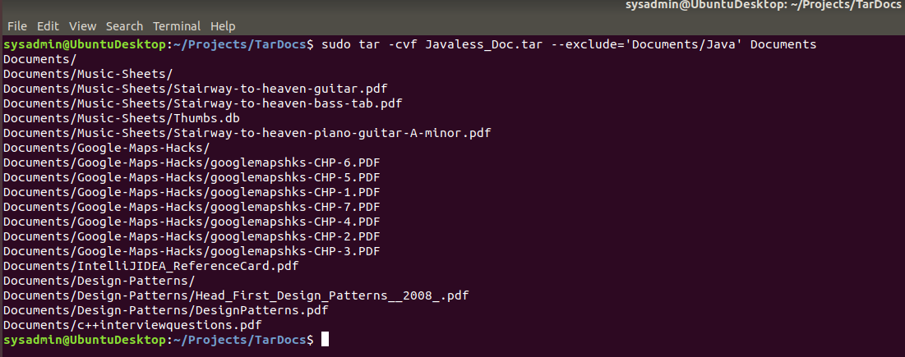
3. Command to ensure Java/ is not in the new Javaless_Docs.tar archive:
   1. sudo tar tvvf Javaless_Doc.tar 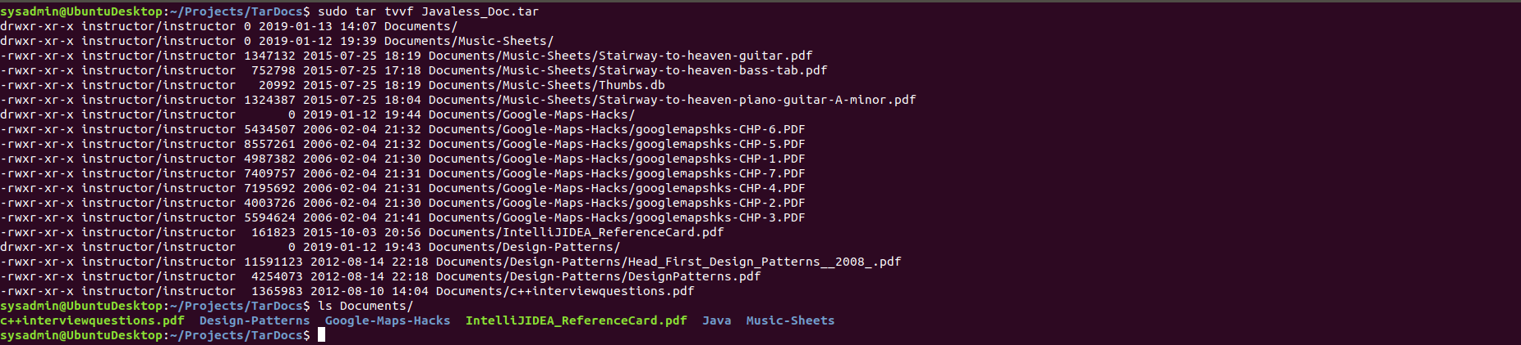

**Step 2: Create, Manage, and Automate Cron Jobs**

1. Cron job for backing up the /var/log/auth.log file: 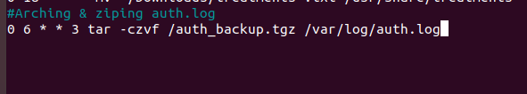

**Step 3: Write Basic Bash Scripts**

1. Brace expansion command to create the four subdirectories: mkdir ~/backups/{freemem,diskuse,openlist,freedisk}
2. Paste your system.sh script edits below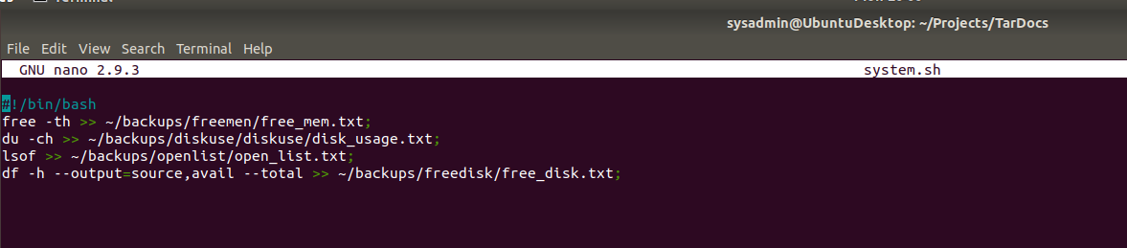
3. Command to make the system.sh script executable: sudo chmod +x system.sh

**Step 4. Manage Log File Sizes**

1. Run sudo nano /etc/logrotate.conf to edit the logrotate configuration file.

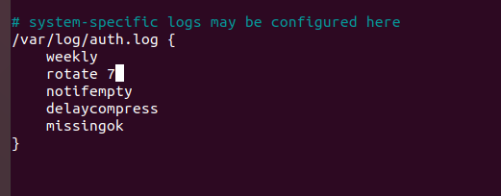

**Bonus: Check for Policy and File Violations**

1. Command to verify auditd is active: systemctl | grep auditd